Class Reg Number

Candidate Name _____________________________

MERIDIAN JUNIOR COLLEGE
JC2 Preliminary Examination
Higher 1

_________________________________________________________________________
H1 Chemistry 8872/01
Paper 1 Multiple Choice 23 September 2010
50 min
Additional Materials: Data Booklet
_________________________________________________________________________

READ THIS INSTRUCTIONS FIRST
Write your name, class and register number in the spaces provided at the top of this page.
There are thirty questions in this section. Answer all questions. For each question, there are four possible answers labeled A, B, C and D.
Choose the one you consider correct and record your choice in soft pencil on the OMR answer sheet.
Read the instructions on the OMR answer sheet very carefully.
You are advised to fill in the OMR Answer Sheet as you go along; no additional time will be given for the transfer of answers once the examination has ended.
Use of OMR Answer Sheet
Ensure you have written your name, class register number and class on the OMR Answer Sheet.
Use a 2B pencil to shade your answers on the OMR sheet; erase any mistakes cleanly. Multiple shaded answers to a question will not be accepted.
For shading of class register number on the OMR sheet, please follow the given examples:
If your register number is 1, then shade 01 in the index number column.
If your register number is 21, then shade 21 in the index number column.

DIDATES

This document consists of 13 printed pages.

Section A

For each question there are four possible answers, A, B, C, and D. Choose the one you consider to be correct.

1 In a titration, a 30.0 cm³ sample of 0.05 mol dm⁻³ of the phosphoric acid was found to require 15.00 cm³ of 11.22 g dm⁻³ solution of potassium hydroxide to reach the endpoint.

Which of the following is the salt formed from the reaction?

- KH₂PO₄
- K₂HPO₄
- K₃PO₄
- KPO₃

2 Which species are oxidized and reduced in the following reaction?

IO₃⁻ + 2I⁻ + 6H⁺ + 6Cl⁻ → 3ICl₂⁻ + 3H₂O

species oxidized species reduced
- IO₃⁻ I⁻
- I⁻, IO₃⁻ Cl⁻
- I⁻ IO₃⁻
- H⁺, Cl⁻ IO₃⁻

- Which one of the following ions has more protons than neutrons, and more
electrons than protons?

A He⁺
B OH⁻
C H₃O⁺
D ¹⁴CO₃²⁻

- Which is the most likely shape of a molecule of dinitrogen pentoxide, N₂O₅?

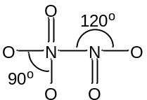
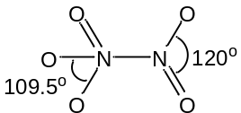
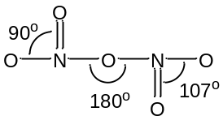
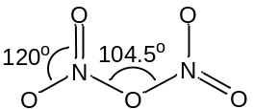
A B C D

- Which of the following molecule is the least soluble in tetrachloromethane, CCl₄?

A Br₂
B NH₃
C H₂O
D CH₃CH₃

- The following shows the energy profile diagram for the forward reaction and the backward reaction of a particular reaction:

A + B → 2C

The activation energy, E_{a} for the forward reaction is +57 kJ mol⁻¹ while that for the backward reaction, E_{a}’ is +85 kJ mol⁻¹.
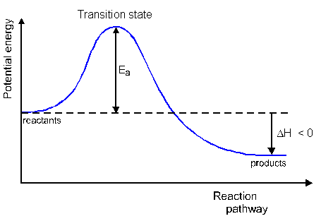

E_{a}

E_{a}’

What is the enthalpy change of reaction for the forward reaction?

A +28 kJ mol⁻¹
B - 28 kJ mol⁻¹
C +56 kJ mol⁻¹
D - 56 kJ mol⁻¹

7 Oxygen reacts with nitrogen monoxide in the equation shown.

O₂(g) + 2NO(g) → 2NO₂(g)

In an experiment to investigate the effects of concentrations on the rate of the reaction, the following results were obtained.

Expt | [O₂] / moldm⁻³ | [NO] / moldm⁻³ | Rate / moldm⁻³s⁻¹
1 | 1.0 | 1.0 | 0.0007
2 | 2.0 | 1.0 | 0.0014
3 | 0.5 | 2.0 | 0.0007
4 | 1.5 | 2.0 | x

The value of x is
A 0.0007
B 0.0014
C 0.0011
D 0.0021

8 The rate of a typical reaction is roughly doubled by raising the temperature by 10 °C. Which of the following statements explains this observation?

A The activation energy is halved when temperature is raised by 10°C.
B The kinetic energy of the molecules is doubled when temperature is raised by 10°C.
C The number of effective collision doubled when temperature is raised by 10°C.
D The number of particles is doubled when temperature is raised by 10°C.

9 For which of the following reactions does K_{c} have the unit mol dm⁻³?
A CH₃OH(l) + CH₃COOH(l) CH₃COOCH₃(l) + H₂O(l)
B 2SO₃(g) 2SO₂(g) + O₂(g)
C CO(g) + H₂O(g) CO₂(g) + H₂(g)
D 2NO₂(g) N₂O₄(g)

10 Deuterium is a heavier isotope of hydrogen. When pure H₂O and pure D₂O are mixed, the following equilibrium is established,
D₂O(l) + H₂O(l) 2HDO(l) ∆H = +55.7 kJ mol⁻¹
Which of the following statement about the reaction is correct?
A The K_{c} expression for the reaction is 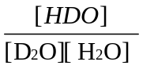
B Increase in temperature will shift the equilibrium position to the left.
C Adding more D₂O will cause equilibrium position to shift right to increase K_{c}.
D The O-D in D₂O and O-H bonds in H₂O have different bond energies from the O-D and O-H bonds in HDO.

11 Which of the following mixtures is not an acid/conjugate base pair?

A H₂O/OH⁻
B H₂PO₄⁻/HPO₄²⁻
C NaH/Na
D NH₃/NH₂⁻

12 Which of the following statements regarding enthalpy change is true?

A ΔH_{rxn}^{θ} is the same regardless of the reaction pathway taken as long as the initial and final conditions are the same.
B ΔH_{c}^{θ} is the energy change when one mole of the substance is burnt in oxygen at 1 atm and 298 K.
C ΔH_{n}^{θ} is the amount of energy released when 1 mole of acid reacts with 1 mole of base at 1 atm and 298 K.
D ΔH_{f}^{θ} is the energy change when 1 mole of substance is formed from its constituent elements at 1 atm and 293 K.

- Which of the following elements is expected to show the least tendency to form covalent compounds?

A Barium
B Calcium
C Caesium
D Potassium

- Which element has the same oxidation number in all of its known compounds?

- Fluorine
- Hydrogen
- Nitrogen
- Phosphorus

15 I, J and K are elements in Period 3. J has a smaller ionic radius than I, and K has a more endothermic first ionisation energy than J.

What are elements I, J and K?

I J K
A P S Cl
B P Mg Al
C Al Mg Si
D Al S P

16 Compound X has the following structure:

CH₃CH=CHCH(Br)CH=CHCH₃

What is the total number of geometric isomers possible for this molecule?

A 1
B 2
C 3
D 4

17 Alkanes can be prepared from bromoalkanes by heating with sodium (in ether) according to the equation:

2RBr + 2Na R-R + 2NaBr

Which alkanes will not be produced if a mixture containing equal amounts of CH₃CH₂Br (bromoethane) and CH₃CHBrCH₃ (2-bromopropane) is used?

A CH₃CH(CH₃)CH(CH₃)₂
B CH₃CH₂CH(CH₃)₂
C CH₃CH₂CH₂CH₃
D CH₃C(CH₃)₃

18 Which of the following compounds form two organic products when it is heated with acidified potassium manganate (VII) solution?

A CH₂=CHCH₂CH=CH₂
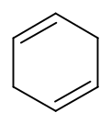

B

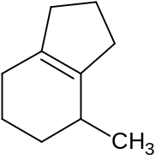

C

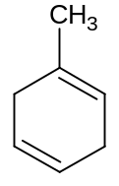

D

19 When 3-methyltoulene is treated with bromine in the presence of FeBr₃, a mixture of two mono-brominated isomers is formed.

What is the structure of these two isomers?
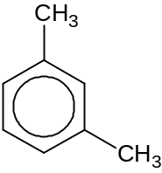

Br₂
2 isomers
FeBr₃
3-methyltoulene

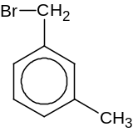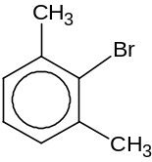

+
A

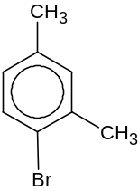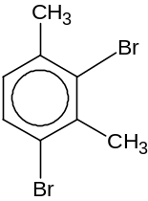

+
B

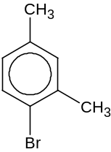

+
C

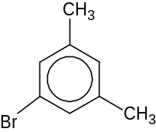

+
D

20 Which of the following pairs react to form more than one organic product under suitable conditions?

A C(CH₃)₄ + limited Cl₂
B CH₃CHBrCH₂CH₃ + KOH in ethanol
C CH₃CH₂CH₂CH₂Br+ KOH in ethanol
D CH₂BrCH₂CH₂CH₃ + aqueous NaOH

21 Compound W is heated in a sealed tube with excess ammonia while compound X is reacted with LiAlH₄ in dry ether.

Which of the following pairs of W and X give the same product?

W X
A BrCH₂CH₂CH₂OH HOOCCH₂CN
B CH₃CH₂CH₂OH CH₃CH₂CN
C (CH₃)₂CHCl (CH₃)₂CHCN
D C₆H₅CHBrCH₂CH₃ C₆H₅CH(CN)CH₂CH₃

22 Ethanol reacts explosively with sodium metal to form a salt, sodium ethoxide, CH₃CH₂O⁻Na⁺.

Given that sodium ethoxide reacts in a similar manner as aqueous sodium hydroxide when added to halogenoalkane, what should be the product formed from the reaction between 2-bromopropane and aqueous sodium ethoxide?

A CH₃CH=CH₂
B (CH₃)₂CHOCH₂CH₃
C CH₃CH₂CH₂OCH₂CH₃
D CH₃CH₂OCH₂CH₃

23 Arrange the following organic compounds in the increasing order of pK_{a} value.

CH₃CH₂OH, CH₃COOH, FCH₂COOH, ClCH₂COOH

A CH₃COOH, FCH₂COOH, ClCH₂COOH, CH₃CH₂OH
B FCH₂COOH, ClCH₂COOH, CH₃CH₂OH, CH₃COOH
C CH₃CH₂OH, CH₃COOH, ClCH₂COOH, FCH₂COOH
D FCH₂COOH, ClCH₂COOH, CH₃COOH, CH₃CH₂OH

24 Which of the following reactions would not produce 1,4-dicarboxylic acid?

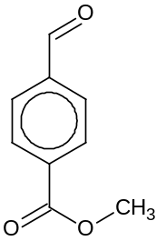A
+ Fehling’s solution and heat followed by
acidification

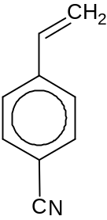B

+ hot acidified potassium manganate (VII)

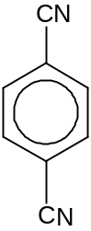
C

+ aqueous H₂SO₄, heat

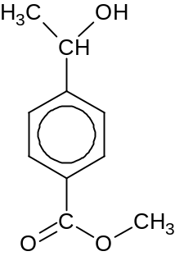
D

+ alkaline aqueous iodine and heat followed by
acidification

25 Compound E is subjected to the following tests and the results were recorded below.

Reagents and conditions Observations
Test 1: Acidified KMnO₄ and heat Purple solution turns colourless
Effervescence of colourless gas that turns limewater chalky

Test 2: Tollen’s reagent and warm Silver mirror formed

Which of the following could be compound E?
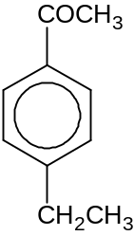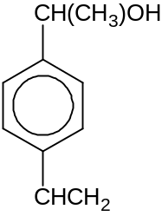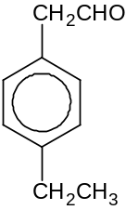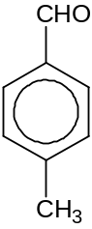
A B C D

For questions 26 to 30, one or more of the three numbered statements 1 to 3 may be correct.

Decide whether each of the statements is or is not correct (you may find it helpful to put a tick against the statements which you consider to be correct.)

The responses A to D should be selected on the basis of

A | B | C | D
1, 2 and 3 are correct | 1 and 2 only are correct | 2 and 3 only are correct | 1 only is correct

- Which of the particles has a half-filled p-subshell when an electron is lost?

- C⁺
- N⁻
- O

27 Water can undergo auto-ionization as follow:

H₂O H⁺ + OH⁻

K_{w} at 25°C | K_{w} at 60°C
1.00 x 10⁻¹⁴ | 9.5 x 10⁻¹⁴

Which of the following statements about this reaction is true?

- The auto-ionization of water is endothermic
2 The pOH of water is 7.49 at 60°C
3 Water is acidic at 60°C

28 The diagram illustrates the energy changes for a set of reactions
ΔH₂ < 0
R
S

ΔH₃ > 0
ΔH₁ > 0

U
T
ΔH₄ > 0

Which of the following statement(s) is/are correct?

- The enthalpy change from S to T is equal to ΔH₃ - ΔH₄ which is also equal to ΔH₁ - ΔH₂
2 The enthalpy change from U to R is exothermic
3 IΔH₃I > IΔH₂I

The responses A to D should be selected on the basis of

A | B | C | D
1, 2 and 3 are correct | 1 and 2 only are correct | 2 and 3 only are correct | 1 only is correct

29 Which of the following reactions will give similar side products?

1 Bromine and cyclohexene
2 Bromine and cyclohexane in the presence of uv light
3 Bromine and benzene in the presence of Fe

30 The pinacol rearrangement involves the reaction of a diol in acidic conditions to form a carbonyl compound as shown below.

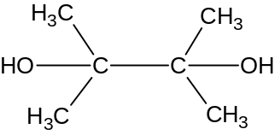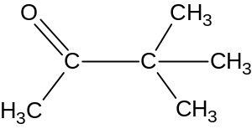
H⁺
+ H₂O

2,3-dimethylbutan-2,3-diol 3,3-dimethylbutan-2-one

Which one of the following structural formula is a product of the pinacol rearrangement of 3,4-dimethylhexa-3,4-diol with the structure as shown below?
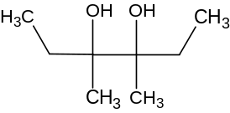

3,4-dimethylhexa-3,4-diol

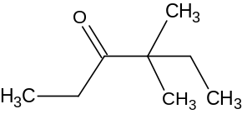
1

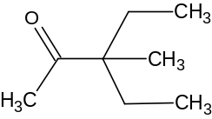
2

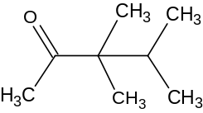

3

Paper 1 Answers

1 | B | 2 | C | 3 | B | 4 | C | 5 | C
6 | B | 7 | D | 8 | C | 9 | B | 10 | D
11 | C | 12 | A | 13 | C | 14 | A | 15 | A
16 | C | 17 | D | 18 | D | 19 | C | 20 | B
21 | A | 22 | B | 23 | D | 24 | A | 25 | D
26 | C | 27 | B | 28 | A | 29 | C | 30 | B

